**COPY/PASTE THE FOLLOWING TEXT FOR YOUR EMAIL:**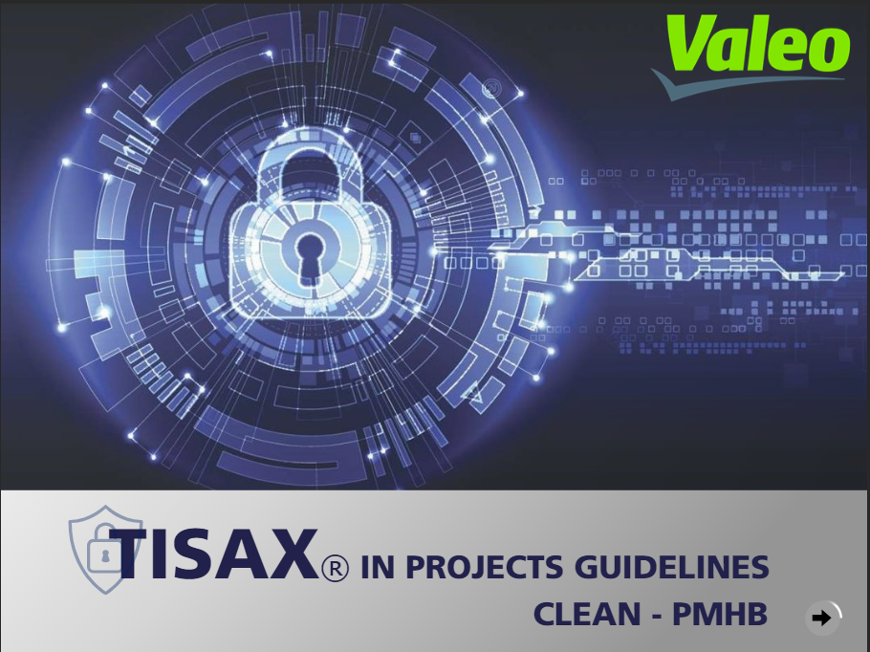

**From:** Valeo project manager

**To:** Customer YYYY

**CC:** valeo.cybersecurity-exemption.mailbox@valeo.com

Dear Mrs / Mr XXXX

Following our last discussion on Month / Day / Year - Valeo acknowledges Your decision that for the Project XXX - email exchanges between Valeo and XXX will not be encrypted as required by TISAX referential.

Best Regards

CC: Valeo Chief Information Security Officer

YYYYY

Valeo Project Manager



* Text in BLUE has to be adapted